CHAPTER 1

1. INTRODUCTION
Chatting is a method of using technology to bring people, ideas and thoughts together despite of the geographical barriers which impose severe socioeconomic costs across the world. “Bling”, our application, is a chatting application which runs on any PC and mobile on the network. It provides a platform to share text and other media.” Bling” allows users to get to interact with each other and share media files. “Bling” is built using Meteor, Angular, and the Ionic Framework for CSS and mobile components. It provides multiple utilities integrated with chatting including group creation and helps in decision making by providing the feature of polling. Thereby it generates graphical representation of the data in the form of pie chart.
Bling has a feature of money distribution which manages the total expenditure of the group and divides it among all the members and notify them by generating messages of the respective part in the contribution.
Thus, “Bling” is a complete package of chatting, managing, decisive and interactive application which connects people; enable them to exchange their ideas and files. There are multiple applications enforcing single functionality which engenders a need to maintain them separately. “Bling” ameliorates the situation by integrating all functionalities under one umbrella. That is it integrates feature like sharing text messages, media files, timed snaps, evaluating media shared, data used, polling, money distribution and many more.

RATIONALE
The communication process has undergone a drastic change over the years. It has travelled quite a long distance right from the era of sending handwritten letters to the present age of instant messaging. Today business is encountering a fierce competition in the market and so the need for real-time communication has augmented. Just a decade ago, the SMS was the order of the day, but with the evolution of time, the popular chat based apps have substituted its place. And it be clear-cut, one must thank the emergence of the Smartphone which has played a dominant role. Bling, at its core, is a messaging service built for web and Smartphone, relying on internet connection or mobile phone data. Cheaper than service provided SMS services, some chat apps operate on low cost subscription models but the most of them are free. Each successful real time chat app has salient features to draw in new users, and it’s this good functionality that rests at the core of a successful chat app.

1.2 PROBLEM DEFINITION
The most common activity which occurs has a direct relation to one thing, express idea and exchange thoughts. By adding the chat option in your application, you are moving towards the customer-centric approach which means you are concerned regarding your clients. You might have provided Toll free numbers or the email option, where the customer can ask his queries but with the passage of time, they are not preferred options. Most of the clients appreciate quick response which the emails and the call centers fail to provide.
If you think that the different chatting tools are only for sending text messages, you might have to reconsider your decision. They are one of the most vital apps for social media networking nowadays and surely they have lot more to offer. But no existing chat application have features like group chats, send multiple media, create timed photograph, manage money distribution, pole, data analysis of media shared, free calls, video calls etc all in one.
Bling is a chat application which is not restricted to sending text messages or media but an application which provides all the above features amalgamated.
To include international numbers poses a critical problem in various chatting application. Thus, limiting the scope of using the application country specific. Bling has no such constraint.

1.3 OBJECTIVE & SCOPE

A single chat application can:
- Run as web application as well as mobile application.
- Validate user’s authentication by sending one time password.
- Allow exchange of not only text messages but other media including picture, video, contacts etc.
- Record real time audio messages and share.
- Share geo-location.
- Set profile picture, status and other profile setting.
- Provide polling feature which presents pictorial representation of the result.
viii) Provide analysis of data used and media shared.
ix) Provide money distribution feature in a group.

1.4 REPORT ORGANIZATION
The report of the project “Bling” describes the various system analysis, design, implementation process, test cases and conclusions.
- Section 1: (Introduction) provides an overview of the entire SRS document and the software being developed.
- Section 2: (Literature Survey) describes the present existing system and theories that are presented in past in relevance with this system. It also states the limitations and technologies used in these existing project and researches.
- Section 3: (System Analysis) contains information about the software that is proposed and its dependencies, limitations and characteristics.
- Section 4: (System Design) describes the various tasks that are to be performed, in response to user requests of the system, taking a Use Case form, display modes and devices supported by the product. It also describes the non-functional requirements of the project including reliability, performance etc.
- Section 5: (Project Implementation) outlines the flow of the software using various UML diagrams such as Sequence, Activity Diagram.
- Section 6: (Test Case Design) provides the description of the changes and scope that can be implemented in the project in future.
- Section 7: (Output Screens)
- Section 8: (Conclusion)

CHAPTER 2

2. LITERATURE SURVEY
Review of literature is important in any research work. Many researchers have carried out research work in the area of applications of human communication. With the increasing use of instant messaging as a communication tool, research on alerting and disruption have recently produced a lot of studies aimed at better understanding the impact of this communication interface on daily working tasks

2.1 background
Implementing a chat server application is one of the most popular network programming projects with newbie programmers. Tons of free source code is available on the web. Excellent highly configurable applications are available both as open source well as proprietary software. There are some numerous examples of open source chat applications implemented we see today.
Although the use of asynchronous online communication environments has been quite extensively researched, less has been written about synchronous environments. These are distinctive in several ways, for example, writing regarding a web-based forum, report that students do not appear to use threads in a useful way. It is the nature of the pooling of knowledge that contributions are often not conveniently clustered into a topic thread. Although synchronous environments are distinctive in several respects, there are also a number of contextual issues that influence their success that they share with asynchronous environments. For example, although the idea of blended learning is now widespread, this mostly considers mixing asynchronous web-based materials with face-to-face teaching.

2.1.1 Whatsapp
WhatsApp Messenger is a freeware and cross-platform messaging and Voice over IP (VoIP) service. The application allows the sending of text messages and voice calls, as well as video calls, images and other media, documents, and user location. The application runs from a mobile device though it is also accessible from desktop computers; the service uses standard cellular mobile numbers. Originally users could only communicate with other users individually or in groups of individual users, but in September 2017 WhatsApp announced a forthcoming business platform which will enable companies to provide customer service to users at scale.
The client was created by WhatsApp Inc., based in Mountain View, California, which was acquired by Facebook in February 2014 for approximately US$19.3 billion. By February 2018, WhatsApp had a user base of over one and a half billion, making it the most popular messaging application at the time. WhatsApp has grown in multiple countries, including Brazil, India, and large parts of Europe, including United Kingdom and France.
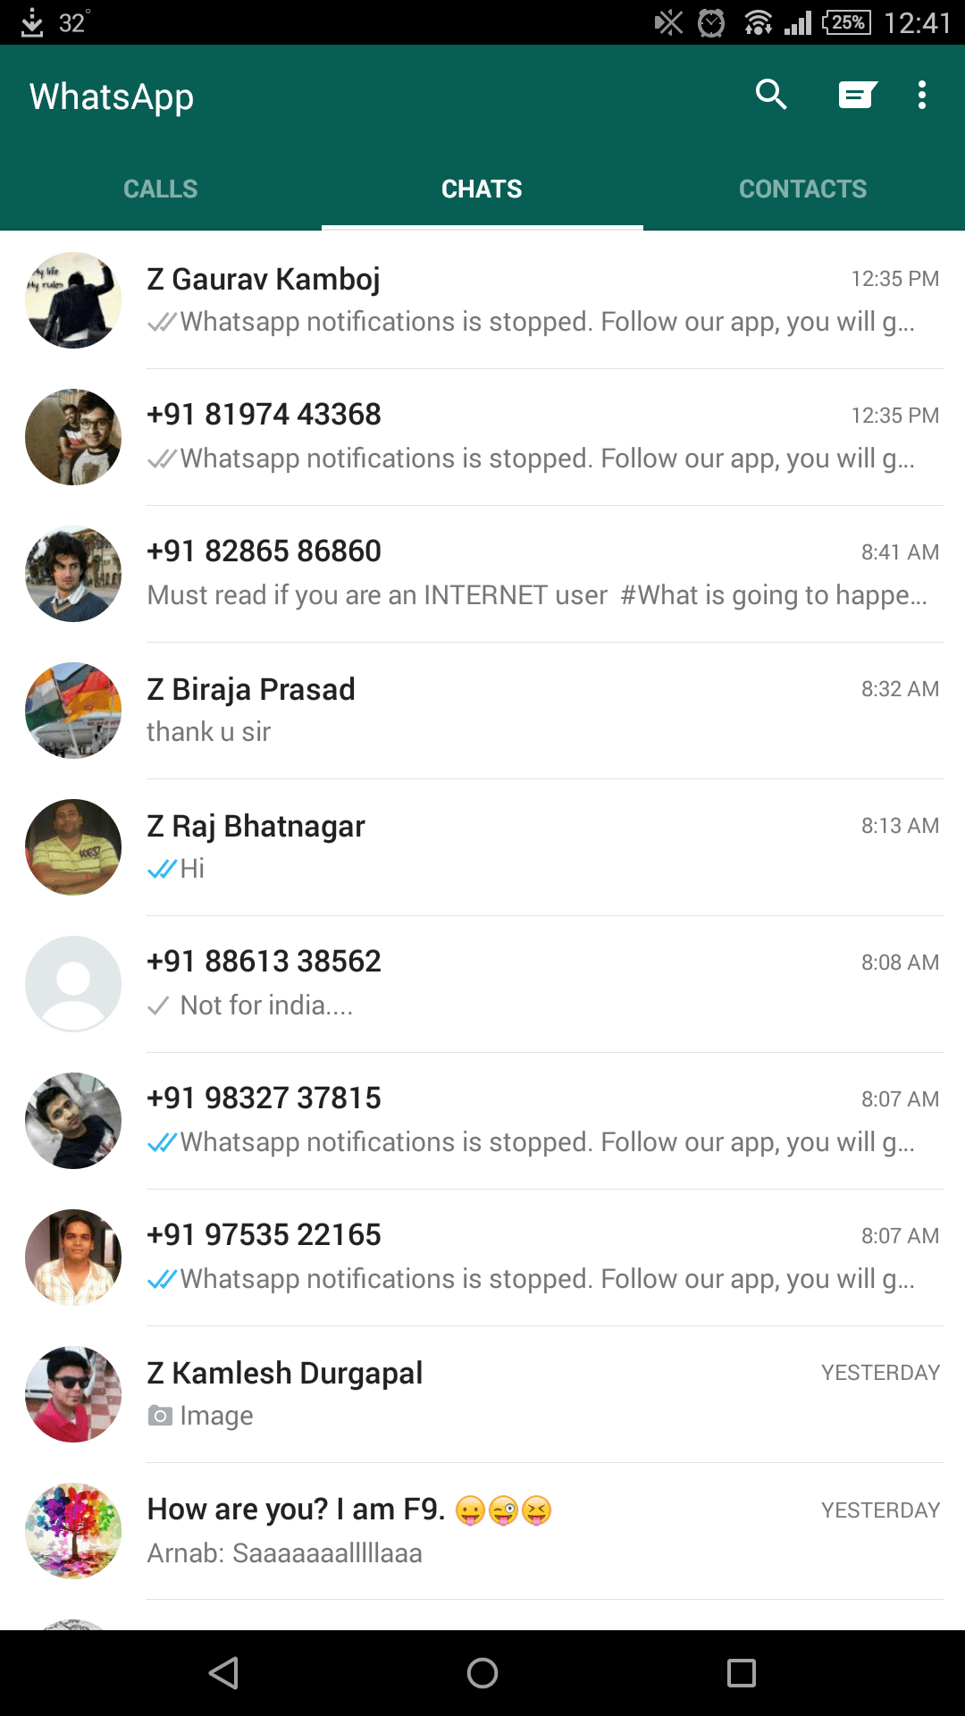

2.1.2. Hike
Hike Messenger is an Indian messaging app. Launched on 12 December 2012, Hike attained 15 million users in February 2014 and raised $14 million for its development. Over the next few months, the application introduced free text messaging across India, chat themes, updated stickers, hidden chats and revamped user interface. In August 2014, Hike reached 35 million users and raised $65 million in a funding round led by Tiger Global.
Hike Messenger made its first acquisition in 2015, buying free voice-calling company Zip Phones, which allowed it to launch free app based calling services that are emerging as a key draw for users.
In 2015 Hike launched the "Great Indian Sticker Challenge" to invite designers to design new stickers. According to the company, 30% of the traffic comes from stickers.
In October 2015, the CEO of Hike announced that the user base of Hike had reached 70 million, with more than 20 billion messages shared each month. and in December according to hike blog hike is sharing over 1 billion messages every single day and 30 billion+ messages a month. In January 2016, Hike crossed registered over 100 million users. "Crossing 100 million users is a milestone for us and we have achieved this magic number well ahead of our expectations," Hike Messenger founder and CEO Kavin Bharti Mittal said in a statement.`
In June 2017, Hike announced the launch of Hike 5.0 along with Hike Wallet. It became the first Indian messaging app to launch payments after this announcement. In addition to the Hike Wallet, Hike launched multiple new features including 10 new App Themes, a Night Mode and Magic Selfie. It also brought back its Timeline feature after multiple user requests.
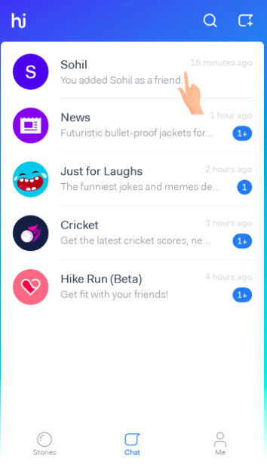

2.1.3 Facebook Messenger
Facebook Messenger (sometimes abbreviated as Messenger) is a messaging app and platform. Originally developed as Facebook Chat in 2008, the company revamped its messaging service in 2010, and subsequently released standalone iOS and Android apps in August 2011. Over the years, Facebook has released new apps on a variety of different operating systems, launched a dedicated website interface, and separated the messaging functionality from the main Facebook app, requiring users to use the web interface or download one of the standalone apps.
Users can send messages and exchange photos, videos, stickers, audio, and files, as well as react to other users' messages and interact with bots. The service also supports voice and video calling. The standalone apps support using multiple accounts, conversations with optional end-to-end encryption, and playing games.
After being separated from the main Facebook app, Messenger had 600 million users in April 2015, growing to 900 million in June 2016, 1 billion in July 2016, and 1.2 billion in April 2017.

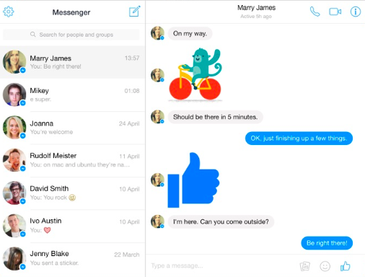

2.2 RELATED WORKS
Secure Chat originated more than 2 years ago as a project for BlackBerry 7. The Client wanted a simple application with minimal functionality and maximum security that would be realized via encryption. Only then would the software grow several essentials, such as automatic deletion of messages or hiding the app icon from the homescreen. Afterwards building a version for Android was just a matter of time. While BlackBerry has always had the reputation of a secure platform with a tiny marketshare, Android, on the contrary, is the most widespread player on the market, and at the same time the most vulnerable as for security. Yet it's security that is the cornerstone of Secure Chat, if only for the fact that data aren't stored on the server. Thus it's useless to hack it. Everything is stored on the devices only, all the peer-to-peer transmitted data are encrypted, and the users are verified via the Off-The-Record protocol. A loss of a device is not a problem either – there is a feature of remote wiping of all data.

This case was considered to be worth studying because the problems of the environment were a feature of most tutorial work undertaken in the school, and because a solution of this kind would be a relatively cheap enhancement to the learning environment. The aims of the research, then, were to monitor and report on the success or otherwise of the chat facility, to provide guidance in improving this as an aid to learning and to offer guidelines to those attempting a similar approach.
CHAPTER 3

3. SYSTEM REQUIREMENT SPECIFICATION

3.1 HARDWARE REQUIREMENTS

- Processor Type : Intel® Core™ i5-6200U CPU
- Processor speed : 2.30 GHZ
- Hard Disk : 500 GB
- RAM : 4 GB

3.2 SOFTWARE REQUIREMENTS

At Server Site: The minimum system requirements at the server end are:
Operating System : Windows/IOS
Processor : Intel Core i5-6200U CPU
Hard Disk : 1 TB
Processor speed : 2.3 GHZ
RAM : 4 GB

At Client Site: The minimum system requirements at the client end are:
Operating System : Windows/IOS
Processor : Pentium III-900 MHZ
Hard Disk : 20 GB
Processor speed : 900 MHZ
RAM : 128 MB

3.3 COMMUNICATIONS INTERFACES
The analyzing website “Accident Analysis” will support the following interfaces protocols for maintaining communication between client and the server:
- IP (Internet Protocol): It is the primary protocol for delivering distinguished protocol datagrams (packets) from source to destination solely based on their addresses.
- FTP (File Transfer Protocol): It is used to exchange and manipulate files over a TCP/IP based network. It is built on client-server architecture and utilizes separate control and data connections between the client and server applications.
- HTTP (Hypertext Transfer Protocol): It is a protocol for distributed, collaborative, hypermedia information systems. It is used for retrieving inter-linked resources, called hypertext documents, led to the establishment of the WWW in 1990.

CHAPTER 4
4. SYSTEM ANALYSIS AND DESIGN
4.1 SYSTEM ANALYSIS
Systems analysis and design refers to the process of examining a business situation with the intent of improving it through better procedures and methods. Systems development can generally be thought of as having two major components: Systems Analysis and Systems Design.
Systems design is the process of planning a new system or replace or complement an existing system. But before this planning can be done, we must thoroughly understand the existing system and determine how computers can best be used to make its operation more effective.
Systems analysis, then, is the process of gathering and interpreting facts, diagnosing problems and using the information to recommend improvement to the system.
Existing System:
The existing communication system is not built as a software application. Everybody communicates with others physically or through the mails. To make this complex communication job simple and allows the users to participate in live communication and save unproductive time it is to be built as a software application.
Each and every user or employee of an organization has to register, get into his inbox and check for his mail which doesn’t provide live communication resemblance to the user. This facility does not categorize the users depending on their interests. This type of communication channel fails in providing effective user friendly communication between the users. If this channel grows up to some extent then it will be harder to place some restrictions on the users. As a result, ineffective communication wastes the user time.
Proposed System:
The first step of analysis process involves the identification of need. The success of a system depends largely on how accurately a problem is defined, thoroughly investigated and satisfying the customer needs by providing user friendly environment
This system has been developed in order to overcome the difficulties encountered while using the mailing system for communication between the users. Providing user friendly communication channel, live communication facility, categorizing the users, logging the communication transaction, sending public & private messages, sending instant & offline messages, graphical communication are motivating factors for the development of this system.

4.1.1 Requirement Analysis
Requirements are a description of how a system should behave or a description of system properties or attributes. It can alternatively be a statement of „what‟ an application is expected to do. The Software Requirements Analysis Process covers the complex task of eliciting and documenting the requirements of all these users, modeling and analyzing these requirements and documenting them as a basis for system design. Requirements analysis is critical to the success of a development project. Requirements must be documented, actionable, measurable, testable, related to identified business needs or opportunities, and defined to a level of detail sufficient for system design. Requirements analysis in systems engineering and software engineering, encompasses those tasks that go into determining the needs or conditions to meet for a new or altered product, taking account of the possibly conflicting requirements of the various stakeholders, such as beneficiaries or users.
4.1.2 Object Oriented Analysis
Whereas structured analysis regards processes and data as separate components, object-oriented analysis combines data and the processes that act on the data into things called objects. Object-oriented analysis defines the different types of objects that are doing the work and interacting with one another in the system and by showing user interactions, called use cases, are required to complete tasks. Systems analysts use O-O methods to model real-world business processes and operations. The result is a set of software objects that represent actual people, things, transactions, and events. Using an O-O programming language, a programmer then transforms the objects into reusable code and components. In the system analysis or object-oriented analysis phase of software development, the system requirements are determined, the classes are identified and the relationships among classes are identified. The three analysis techniques that are used in conjunction with each other for object-oriented analysis are object modeling, dynamic modeling, and functional modeling.

4.1.2.1 Object Modeling
Object modeling develops the static structure of the software system in terms of objects. It identifies the objects, the classes into which the objects can be grouped into and the relationships between the objects. It also identifies the main attributes and operations that characterize each class.
The process of object modeling can be visualized in the following steps:
- Identify objects and group into classes
- Identify the relationships among classes
- Create user object model diagram
- Define user object attributes
- Define the operations that should be performed on the classes
- Review glossary

4.1.2.2 Dynamic Modeling
After the static behavior of the system is analyzed, its behavior with respect to time and external changes needs to be examined. This is the purpose of dynamic modeling.
Dynamic Modeling can be defined as “a way of describing how an individual object responds to events, either internal events triggered by other objects, or external events triggered by the outside world”.
The process of dynamic modeling can be visualized in the following steps:
- Identify states of each object
- Identify events and analyze the applicability of actions
- Construct dynamic model diagram, comprising of state transition diagrams
- Express each state in terms of object attributes
- Validate the state–transition diagrams drawn

4.1.2.3 Functional Modeling
Functional Modeling is the final component of object-oriented analysis. The functional model shows the processes that are performed within an object and how the data changes as it moves between methods. It specifies the meaning of the operations of object modelling and the actions of dynamic modeling. The functional model corresponds to the data flow diagram of traditional structured analysis.
The process of functional modeling can be visualized in the following steps:
- Identify all the inputs and outputs
- Construct data flow diagrams showing functional dependencies
- State the purpose of each function
- Identify constraints
- Specify optimization criteria

4.1.3 Feasibility Analysis
Feasibility analysis determines the strengths and weaknesses of proposed venture, opportunities, risk involved in running a software project and assets needed to carry through a project i.e. feasibility study has significant impact to run a software project successfully.
When the client approaches the organization for getting the desired product developed, he comes up with rough idea about what all functions the software must perform and which all features should be present in the software. Referencing to this information, the analysts does a detailed study about whether the desired system and its functionality are feasible to develop. This feasibility study is focused towards goal of the organization.
This study analyzes whether the software product can be practically materialized in terms of implementation, contribution of project to organization, cost constraints and as per values.
Feasibility analysis is commonly performed by project manager or business analyst. Significant part of feasibility analysis is done by business analysts in which they establish communication and collaboration between the business and IT. For running a successful business they do—
4.1.3.1Technical Feasibility
Analysis of available technical resources and their applicability to fulfill the need of proposed system ..The technical feasibility assessment is focused on gaining an understanding of the present technical resources of the organization and their applicability to the expected needs of the proposed system. It is an evaluation of the hardware and software and how it meets the need of the proposed system and determines whether the technology needed for the proposed system is available or not.
Can the work for the project be done with current equipment existing software technology & available personal? Can the system be upgraded if developed? The proposed system can be implemented using existing technology and the design of the system can run on the real environment, so there is no development risk.
4.1.3.2 Behavioral Feasibility
People are inherently resistant to change, and computers have been known to facilitate change. An estimate should be made of how strong a reaction the user staff is likely to have toward the development of a computerized system. [t is common knowledge that computer installations have something to do with turnover, transfers, retraining, and changes in employee job status. Therefore, it is understandable that the introduction of a candidate system requires special effort to educate, sell, and train the staff on new ways of conducting business
- Is the audience likely to adopt the behavior?
- How costly is it (time, effort, resources) for the audience segment to perform the behavior?
- How complex is the behavior (does it involve few or several elements)?

4.1.3.3Operational Feasibility
Operational feasibility is the measure of how well a proposed system solves the problems, and takes advantage of the opportunities identified during scope definition and how it satisfies the requirements identified in the requirements analysis phase of system development.
The operational feasibility assessment focuses on the degree to which the proposed development project fits in with the existing business environment and objectives with regard to development schedule, delivery date, corporate culture and existing business processes.

4.1.4 Development Method
After designing the new system, the whole system is required to be converted into computer understanding language. Coding the new system into computer programming language does this. It is an important stage where the defined procedures are transformed into control specifications by the help of a computer language. This is also called the programming phase in which the programmer converts the program specifications into computer instructions, which refer as programs. The programs coordinate the data movements and control the entire process in a system.
Our development occurred in following phases
- Platform selection: Meteor, Ionic, Angular, Webpack
- Observed a tutorial site of https://angular-meteor.com/tutorials/whatsapp/meteor/bootstrapping
- Created new design of the system
- Received user reviews.

4.2 SYSTEM DESIGN

Systems design is the process of defining the architecture, modules, interfaces, and data for a system to satisfy specified requirements. Systems design could be seen as the application of systems theory to product development. There is some overlap with the disciplines of systems analysis, systems architecture and systems engineering. This section contains the software requirements to a level of Detail sufficient to enable designers to design the system and the Testers to test the system.

4.2.1 Use Case Diagram

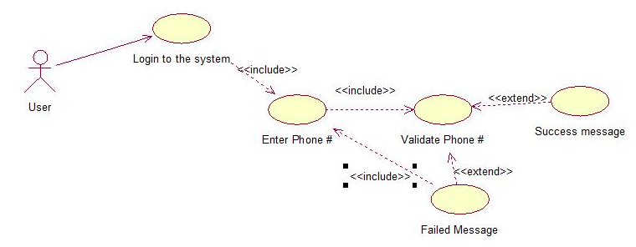

Fig.4.1: Use Case Diagram

4.2.2 Use Case Specification:
There is one actor in the project, the user that logs in our application.

4.2.2.1 User’s Functionalities:
- Login to the System: The user is provided with the functionality to login i.e. create account.
- Enter phone number: According to the rules applied the accounts are obtained using the verification process.
- Give Feedback: The user is given the facility to submit feedbacks in the feedback section.

4.2.3 Activity Diagram
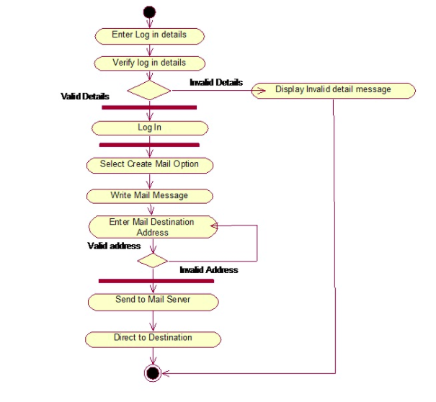

Fig 4.2: Activity Diagram

4.2.4 Sequence Diagram

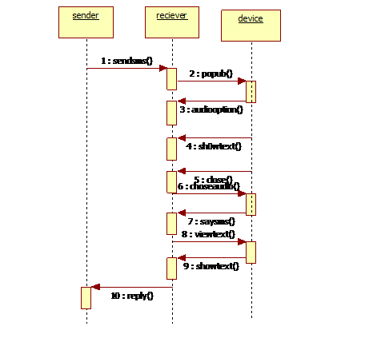

` Fig 4.3 : Sequence Diagram

4.2.5 Class Design

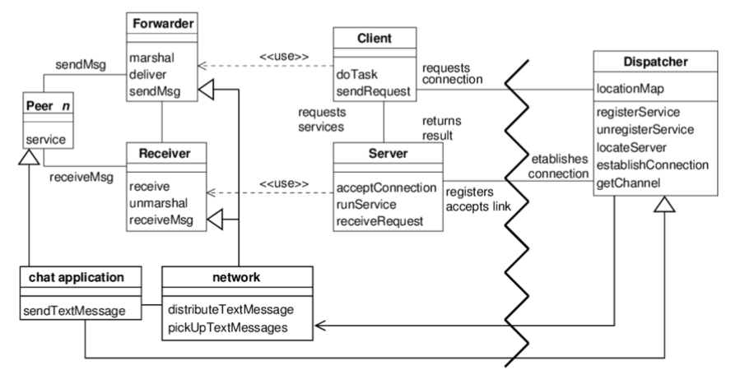
Fig 4.4: Class Design

4.2.6 Data Model (ER Diagram)

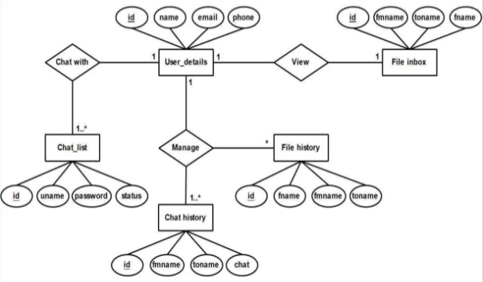

Fig 4.5 : E R Diagram

4.2.7 Data flow Diagram
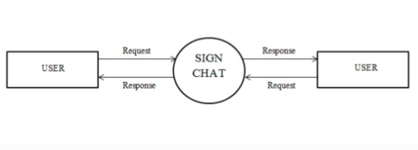

Fig 4.6: Data flow Diagram

CHAPTER 5

5. PROJECT IMPLEMENTATION & OUTPUT SCREENS

5.1 PROJECT IMPLEMENTATION
In this project, in order to reduce the overhead of handling multiple applications and use the space more efficiently, we created a chatting application which combines the feature of multiple applications introducing features such as polling, money splitting, timed snaps and data analysis
Data analysis is a process for obtaining raw data and converting it into information useful for decision making by user.
It works on Android, IOS as well as Windows.
- Firstly the user will enter the mobile number and get a onetime verification code.
- The user data is inserted into the meteor database.
- Each user’s data is stored in the database in unstructured form including their profile data, text messages and media shared between contacts.
- User can add people from its contact list to chat.
- User can also form group of multiple people.
- User can initiate polling questions with multiple options. The result will be represented as a pie chat.
- User can enter total expenditure and money distribution feature can equally divide the money amongst the group members.
- The data used and the media sent can be analysed and represented in the form of a bar graph.
- User can share timed photograph which will be deleted automatically after a timer set.
- Every time user logs out, he needs to generate the verification code to login.

5.1.1 User Interface
This chatting is available in form of website and mobile application. This website/application will provide a very intuitive and simple interface to the user so that the user can easily navigate through pages. Users will be able to view the chat and profile.
The following Window will be provided:
- LOGIN PAGE: It enters the phone number and generates onetime verification code.
- VERIFICATION PAGE: It directs to the profile setting page.
- PROFILE SETTING PAGE: It consists of name, profile picture and status options and done button. It directs to the home page.
- HOME PAGE: It consists of the chats records which direct to chat page. It also consists of add chat option and menu options.
- CHAT PAGE: It consists of the complete chat between the recipients.

5.1.2 Screenshots

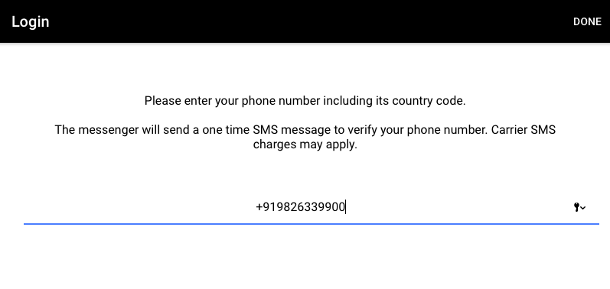
Fig 5.1: Login Page

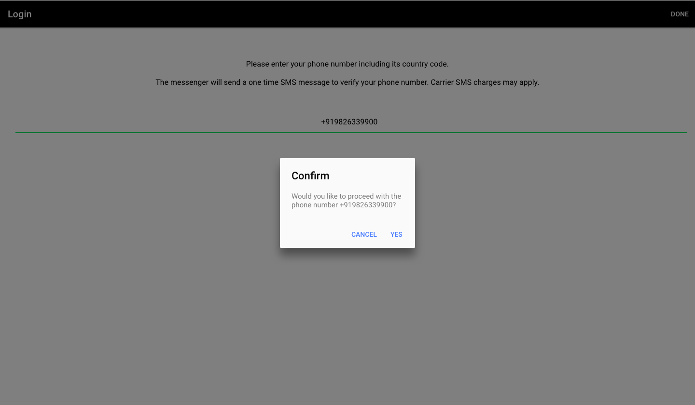

Fig 5.2: Login Page

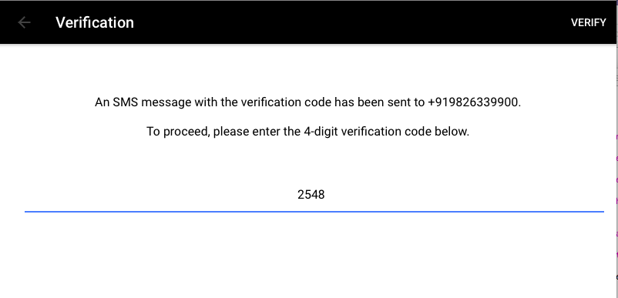
Fig 5.3: Verification Page
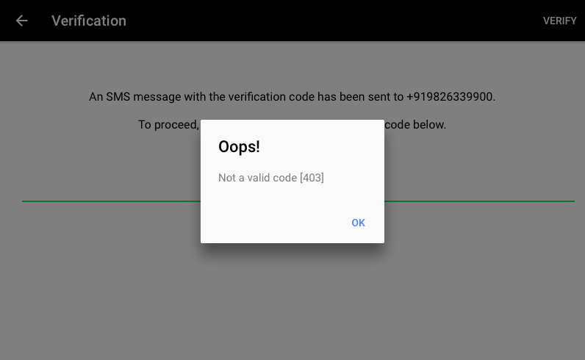
Fig 5.4: Verification Page

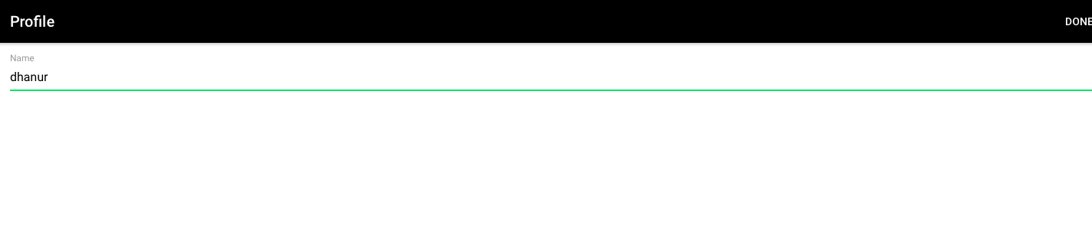
Fig 5.5: Profile Setting Page

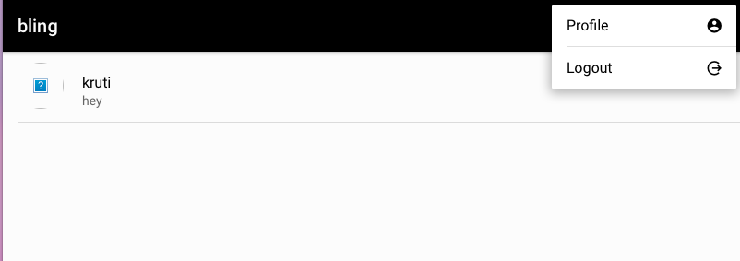
Fig 5.6: Home Page

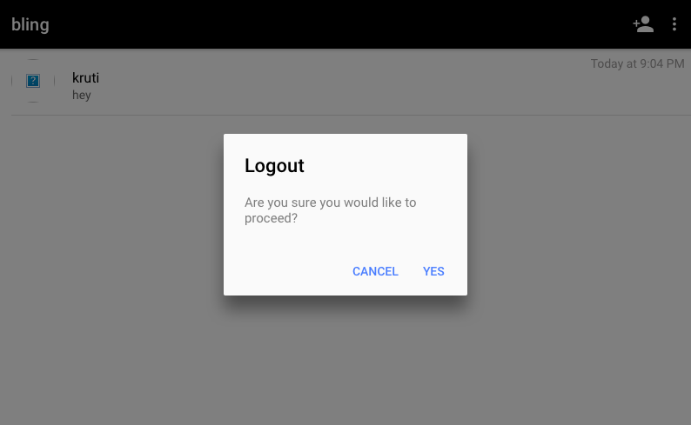

Fig 5.7: Home Page

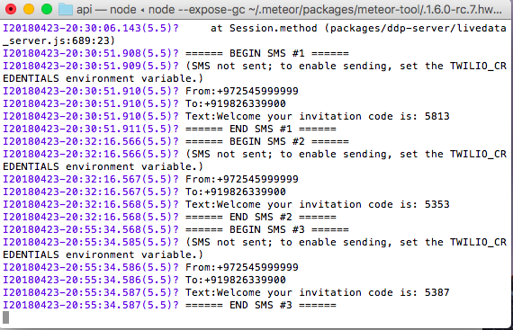

Fig 5.7: Terminal Window

5.2 Important Coding

Message .ts

import { Component, OnInit, OnDestroy, ElementRef } from '@angular/core';

import { NavParams } from 'ionic-angular';

import { Chat, Message, MessageType } from 'api/models';

import { Messages } from 'api/collections';

import { MeteorObservable } from 'meteor-rxjs';

import * as moment from 'moment';

import * as _ from 'lodash';

@Component({

selector: 'messages-page',

templateUrl: 'messages.html'

})

export class MessagesPage implements OnInit, OnDestroy {

selectedChat: Chat;

title: string;

picture: string;

messagesDayGroups;

message: string = '';

autoScroller: MutationObserver;

scrollOffset = 0;

senderId: string;

constructor(

navParams: NavParams,

private el: ElementRef

) {

this.selectedChat = <Chat>navParams.get('chat');

this.title = this.selectedChat.title;

this.picture = this.selectedChat.picture;

this.senderId = Meteor.userId();

}

private get messagesPageContent(): Element {

return this.el.nativeElement.querySelector('.messages-page-content');

}

private get messagesList(): Element {

return this.messagesPageContent.querySelector('.messages');

}

private get scroller(): Element {

return this.messagesList.querySelector('.scroll-content');

}

ngOnInit() {

this.autoScroller = this.autoScroll();

this.subscribeMessages();

}

ngOnDestroy() {

this.autoScroller.disconnect();

}

subscribeMessages() {

this.scrollOffset = this.scroller.scrollHeight;

this.messagesDayGroups = this.findMessagesDayGroups();

}

findMessagesDayGroups() {

//let isEven = false;

return Messages.find({

chatId: this.selectedChat._id

}, {

sort: { createdAt: 1 }

})

.map((messages: Message[]) => {

const format = 'D MMMM Y';

// Compose missing data that we would like to show in the view

messages.forEach((message) => {

message.ownership = this.senderId == message.senderId ? 'mine' : 'other';

return message;

});

// Group by creation day

const groupedMessages = _.groupBy(messages, (message) => {

return moment(message.createdAt).format(format);

});

// Transform dictionary into an array since Angular's view engine doesn't know how

// to iterate through it

return Object.keys(groupedMessages).map((timestamp: string) => {

return {

timestamp: timestamp,

messages: groupedMessages[timestamp],

today: moment().format(format) === timestamp

};

});

});

}

autoScroll(): MutationObserver {

const autoScroller = new MutationObserver(this.scrollDown.bind(this));

autoScroller.observe(this.messagesList, {

childList: true,

subtree: true

});

return autoScroller;

}

scrollDown(): void {

// Scroll down and apply specified offset

this.scroller.scrollTop = this.scroller.scrollHeight - this.scrollOffset;

// Zero offset for next invocation

this.scrollOffset = 0;

}

onInputKeypress({ keyCode }: KeyboardEvent): void {

if (keyCode === 13) {

this.sendTextMessage();

}

}

sendTextMessage(): void {

// If message was yet to be typed, abort

if (!this.message) {

return;

}

MeteorObservable.call('addMessage', MessageType.TEXT,

this.selectedChat._id,

this.message

).zone().subscribe(() => {

// Zero the input field

this.message = '';

});

}

}

Chats.ts
import { Component, OnInit } from '@angular/core';
import { Chats, Messages, Users } from 'api/collections';
import { Chat, Message } from 'api/models';
import { MeteorObservable } from 'meteor-rxjs';
import { Observable, Subscriber } from 'rxjs';
import { NavController, PopoverController, ModalController, AlertController } from 'ionic-angular';
import { MessagesPage } from '../messages/messages';
import { ChatsOptionsComponent } from './chats-options';
import { NewChatComponent } from './new-chat';

@Component({
templateUrl: 'chats.html'
})
export class ChatsPage implements OnInit {
chats;
senderId: string;

constructor(
private navCtrl: NavController,
private popoverCtrl: PopoverController,
private modalCtrl: ModalController,
private alertCtrl: AlertController) {
this.senderId = Meteor.userId();

}

addChat(): void {
const modal = this.modalCtrl.create(NewChatComponent);
modal.present();
}

ngOnInit() {
this.chats = this.findChats();
}
findChats(): Observable<Chat[]> {
// Find chats and transform them
return Chats.find().map(chats => {
chats.forEach(chat => {
chat.title = '';
chat.picture = '';

const receiverId = chat.memberIds.find(memberId => memberId !== this.senderId);
const receiver = Users.findOne(receiverId);

if (receiver) {
chat.title = receiver.profile.name;
chat.picture = receiver.profile.picture;
}

// This will make the last message reactive
this.findLastChatMessage(chat._id).subscribe((message) => {
chat.lastMessage = message;
});
});

return chats;
});
}

findLastChatMessage(chatId: string): Observable<Message> {
return Observable.create((observer: Subscriber<Message>) => {
const chatExists = () => !!Chats.findOne(chatId);

// Re-compute until chat is removed
MeteorObservable.autorun().takeWhile(chatExists).subscribe(() => {
Messages.find({ chatId }, {
sort: { createdAt: -1 }
}).subscribe({
next: (messages) => {
// Invoke subscription with the last message found
if (!messages.length) {
return;
}
const lastMessage = messages[0];
observer.next(lastMessage);
},
error: (e) => {
observer.error(e);
},
complete: () => {
observer.complete();
}
});
});
});
}

showMessages(chat): void {
this.navCtrl.push(MessagesPage, {chat});
}
removeChat(chat: Chat): void {
Chats.remove({_id: chat._id}).subscribe(() => {
});
}

handleError(e: Error): void {
console.error(e);

const alert = this.alertCtrl.create({
buttons: ['OK'],
message: e.message,
title: 'Oops!'
});

alert.present();
}
showOptions(): void {
const popover = this.popoverCtrl.create(ChatsOptionsComponent, {}, {
cssClass: 'options-popover chats-options-popover'
});

popover.present();
}
}

Message.html

<ion-header>

<ion-navbar color="whatsapp" class="messages-page-navbar">

<ion-buttons>

<img class="chat-picture" [src]="picture">

</ion-buttons>

<ion-title class="chat-title">{{title}}</ion-title>

<ion-buttons end>

<button ion-button icon-only class="attach-button"><ion-icon name="attach"></ion-icon></button>

<button ion-button icon-only class="options-button"><ion-icon name="more"></ion-icon></button>

</ion-buttons>

</ion-navbar>

</ion-header>

<ion-content padding class="messages-page-content">

<ion-scroll scrollY="true" class="messages">

<div *ngFor="let day of messagesDayGroups | async" class="day-wrapper">

<div *ngFor="let message of day.messages" class="message-wrapper">

<div [class]="'message message-' + message.ownership">

<div *ngIf="message.type == 'text'" class="message-content message-content-text">{{message.content}}</div>

<span class="message-timestamp">{{ message.createdAt | amDateFormat: 'HH:mm' }}</span>

</div>

</div>

<div *ngIf="!day.today" class="day-timestamp">{{day.timestamp}}</div>

</div>

</ion-scroll>

</ion-content>

<ion-footer>

<ion-toolbar color="whatsapp" class="messages-page-footer" position="bottom">

<ion-input [(ngModel)]="message" (keypress)="onInputKeypress($event)" class="message-editor" placeholder="Type a message"></ion-input>

<ion-buttons end>

<button ion-button icon-only *ngIf="message" class="message-editor-button" (click)="sendTextMessage()">

<ion-icon name="send"></ion-icon></button>

<button ion-button icon-only *ngIf="!message" class="message-editor-button">

<ion-icon name="mic"></ion-icon>

</button>

</ion-buttons>

</ion-toolbar>

</ion-footer>

Chats.scss
.chats-page-content {
.chat-picture {
border-radius: 50%;
width: 50px;
float: left;
}
.chat-info {
float: left;
margin: 10px 0 0 20px;
.last-message-timestamp {
position: absolute;
top: 10px;
right: 10px;
font-size: 14px;
color: #9A9898;
}
}

CHAPTER 6

6.TESTING
6.1 TESTING
Software Testing Documentation is a standard that specifies the form of a set of documents for use in eight defined stages of software testing and system testing, each stage potentially producing its own separate type of document. Testing is a process of executing a program with intend of finding a error. Testing documentation involves the documentation of artifacts that should be developed before or during the testing of Software. Documentation for software testing helps in estimating the testing effort required, test coverage, requirement tracking/tracing, etc.

6.2 TYPES OF TESTING
6.2.1 Unit Testing
In unit testing the individual components are tested independently to ensure their quality. Unit testing is undertaken when a module has been created and successfully reviewed. In order to test a single module we need to provide a complete environment, that is besides the module we would require
• The procedures belonging to other modules that the module under test calls
• Non local data structures that module accesses
• A procedure to call the functions of the module under test with appropriate parameters

6.2.2 Functional Testing
Functional testing is a quality assurance (QA) process and a type of black-box testing that bases its test cases on the specifications of the software component under test. Functions are tested by feeding them input and examining the output, and internal program structure is rarely considered (unlike white-box testing). Functional testing usually describes what the system does. Each functionality of the system is tested by providing appropriate input, verifying the output and comparing the actual results with the expected results. This testing involves checking of User Interface, APIs, Database, security, client/ server applications and functionality of the Application under the test. The testing can be done either manually or using automation Functional testing does not imply that you are testing a function (method) of your module or class. Functional testing tests a slice of functionality of the whole system. Checking of all the linking is performed in following manner:

• Test the outgoing links from all the pages to specific domain under test.
• Test all internal links.
• Test links jumping on the same pages.

Forms are the integral part of any website. Forms are used for receiving information from users and to interact with them. The checking performed in the forms are:
• First check all the validations on each field.
• Check for default values of the fields.

6.2.3 System Testing
System testing is actually a series of different tests whose primary purpose is to fully exercise the computer-based system. Below we have described the two types of testing which have been taken for this project. it is to check all modules worked on input basis .if you want change any values or inputs will change all information. so specified input is must. It includes the following tests
• Reliability Testing: The reliability of the system is that it gives the right result on a search. Measurements obtained from 1000 searches during testing. It must give more than 98% of the search, plan more than 99% of the searches. We wished for 100% of the searches to be successful.
• Usability Testing: The test conducted on various pages and modules and how they are effective for user and how when they are used reach different pages and modules.
• Database Testing: It is checked out that the data entered by user once during registration is safely entered in database without the loss of data and the item information saved in database is also retrieved at time of view product not only this when the admin add, remove or update the information of data , the data is safely added updated and deleted from the table in database. • Security Testing: It is checked that data entered by one person is secure and not visible to other user and the payment done is safely taking place.
• Portability Testing: The application should be portable with browsers like Mozilla firefox, internet explorer and Google chrome. The adaptable platform for the website is to run on. 3.4 Integration Testing In this type of testing we test various integration of the project module by providing the input. The primary objective is to test the module interfaces in order to ensure that no errors are occurring when one module invokes the other module. It tests integration or interfaces between components, interactions to different parts of the system such as an operating system, file system and hardware or interfaces between systems.

6.2.4 Validation Testing
In software project management, software testing, and software engineering, verification and validation (V&V) is the process of checking that a software system meets specifications and that it fulfills its intended purpose. It may also be referred to as software quality control. It is normally the responsibility of software testers as part of the software development lifecycle.

6.2.5 Top-Down Integration
Top-down integration testing is an integration testing technique used in order to simulate the behavior of the lower-level modules that are not yet integrated. Stubs are the modules that act as temporary replacement for a called module and give the same output as that of the actual product. The replacement for the 'called' modules is known as 'Stubs' and is also used when the software needs to interact with an external system.

6.2.6 Bottom-Up Integration
Each component at lower hierarchy is tested individually and then the components that rely upon these components are tested. A driver program is written to co-ordinate test case input and output. The whole cluster is tested. Drivers are removed and clusters are combined moving upward in the program structure.

6.3 TEST APPROACH & TEST PLAN

A test approach is the test strategy implementation of a project, defines how testing would be carried out. A good test case is one that has high probability of finding an undiscovered error. A successful test is one that uncovers an as-yet undiscovered error. Test approach has two techniques:
• Proactive: An approach in which the test design process is initiated as early as possible in order to find and fix the defects before the build is created.
• Reactive: An approach in which the testing is not started until the design and coding are completed.
In this project the Reactive Approach is used and the modules are tested after the complete coding and implementation. In the process, all aspects of the software were tested. Steps to follow while implementing the methodology are as follows:
➢ Start with a base function that is to be implemented.
➢ Creating a document with the detailed requirement definition, an activity diagram with a description of the flow, database tables to be used, a sequential diagram, and a description of each component with the precondition and tables that would be affected by the component.
➢ Giving the document to the tester, and working with the tester while he or she writes the code to check if the steps in the document can be implemented and if the result of each use case can be achieved.
➢ If the tester finds a step difficult to implement or thinks he or she is missing additional information to implement the functionality, then go to step 2; otherwise, go to step 3.
➢ Asking the tester to log on all the errors and difficulties he or she encounters while working on the prototype implementation.
➢ Once the prototype is done and the results between the developer’s prototype and tester’s prototype match, work on the other requirement, and expanding the prototype to final software.
This test plan describes the scope, approach, resources and schedule of intended test activities. It identifies amongst others test items, the features to be tested, the testing tasks, who will do each task, the test environment and the test design technique

6.4 TEST CASES
A test case is a set of conditions or variables under which a tester will determine whether a system under test satisfies requirements or works correctly. The process of developing test cases can also help find problems in the requirements or design of an application. Written test cases should include a description of the functionality to be tested, and the preparation required to ensure that the test can be conducted

CASE | PURPOSE | INPUTS | Expected output | Test Case Description | Test Result

1 | Sign up | User must have input a valid phone number | Redirected to next desired page that is the OTP page | To test the Login/ Authentication interface for user | Successful
1 | Sign up | Admin has input some invalid phone number | The error messages will be displayed to the user on those check fields. | To test the Login/ Authentication interface for user | Successful

2 | OTP | User must enter valid OTP received | Redirected to next desired page that is the Profile page | To test the admin Login functioning | Successful
2 | OTP | User has input some invalid OTP | The error messages will be displayed to the user on those check fields. | To test the admin Login functioning | Successful

3 | Profile | Edit the user information | Updates the user Information

4 | Add Chat | User Must add a chat from the contact list | The chat window of the contact opens | To initiate a chat with a person in the contact list | successful

5 | Remove Chat | User must slide the contact chat to the left to remove chat | It removes the chat | To remove an existing chat | successful

6 | Send Text | User must open the chat by clicking the icon and send the text | It sends the text | To send the text | Successful

7 | Send Attachments | User Must click on the attach icon in the chat window and attach a picture/audio/video/contact and send it | It sends the attachments | To attach the files | Successful

8 | To record and Send Audio | User must click and hold the mic button to record the audio and release | It send the audio files | To record and send audio files | Successful

9 | To display Profile picture | User must click on the profile picture | Picture is displayed | To view the profile picture | Successful

10 | Logout | User Must click the logout button | It logs user out to the login page | To logout from the user account | Successful

CHAPTER 7

7. FUNCTIONAL & NON FUNCTIONAL REQUIREMENT

7.1 FUNCTIONAL REQUIREMENTS
- The users are able to register for the application through a valid phone number.
- On installing the application, user must be prompted to register their phone number. If user skips this step, application should close.
- The user’s phone number will be the unique identifier of his/her
account on application.
- The user has the function of creating, removing the chats at any point.
- The application detects all contacts from the user’s phone book. If any of the contacts have user accounts with application, those contacts must automatically be added to the user’s contact list on application.

- User should be able to send audio, video and images as attachments.
Audio formats that the application should support : mp3 wav
Video formats that the application should support : avi mp4 flv gif
Image formats that the application should support: jpg png
File size must not exceed 2MB per message.

- User should be able to create groups of contacts and broadcast messages to these groups.

7.2 NON-FUNCTIONAL REQUIREMENTS
Quality attributes that can serve as requirements are described below:

7.2.1 Performance:
The performance of the application decreases with the increase in the data. Performance is about the time taken to execute tasks. The quicker a task completes, the better the application is performing.

7.2.2 Reliability:
The application will be very reliable as it has the personal generated data which is private.

7.2.3 Availability:
The application will be accessible from the internet with the need of creating an account.

7.2.4 Maintainability:
The application will be updated with the latest available version.

7.2.5 Portability:
It supports all iOS and android operating system in cellphones.

7.2.6 Response time:
Response time is the total amount of time it takes to respond to a request for service. That service can be anything from a memory fetch, to a disk IO, or loading a full chat page. Ignoring transmission time for a moment, the response time is the sum of the service time and wait time.

7.2.7 Robustness:
Robustness is the ability of a system to cope with errors during execution. Robustness can also be defined as the ability of an algorithm to continue operating despite abnormalities in input, calculations, etc. Robustness can encompass many areas of computer science, such as robust programming, robust machine learning, and Robust Security Network form, the more robust the software. Formal techniques, such as fuzz testing, are essential to showing robustness since this type of testing involves invalid or unexpected inputs. Alternatively, fault injection can be used to test robustness.

7.2.8 Scalability:
Scalability is the ability of a system, network, or process to handle a growing amount of work in a capable manner or its ability to be enlarged to accommodate that growth. Scalability is about the number of tasks a system can execute at the same time. This usually maps almost directly to the number of concurrent users that an application can support.

7.2.9 Security:
Security requirements are included in a system to ensure: Unauthorized access to the system and its data is not allowed and to ensure the integrity of the system from accidental or malicious damage.

7. 2.10 Stability:
Stability is about how many failures an application exhibits; whether that is manifested as unexpected or unintended behavior, users receiving errors, or a catastrophic failure that brings a system down. The fewer failures that are observed the more stable an application is.

7.2.11 Supportability:
How effectively a software system or component can be kept running after deployment, based on resources that include quality documentation, diagnostic information, and both knowledgeable and available technical staff.

7.2.12 Testability:
The degree to which a system can be tested effectively and efficiently. Effectiveness has to do with increasing the depth and quality of tests, where efficiency deals with reducing cost, effort and time of testing. Testability is the ease of validation, the degree to which software can be effectively tested. It plays a role during the initial development of the software and during maintenance, testability can be considered as a capability that enables modified software to be validated.

7.2.13 Fault tolerance:
Fault tolerance is the property that enables a system to continue operating properly in the event of the failure of some of its components. So, this web application will be fault tolerance because it has different-different modules so if one module gets fail then it cannot be affect another module.

CHAPTER 8

8. CONCLUSION
8.1 CONCLUSION:
The generated graphs and charts visualize the data that is accurate and have proven science behind them. The purpose of this project to create an instant messaging service and software application in which users can send messages and exchange photos, videos, audio, and files, as well as react to other users' messages, is fulfilled.

8.2 FUTURE ENHANCEMENT:
- It can be implemented for more complex features in order to enhance the feature of interactions amongst people. An important goal of the application is to shape future development in the Meteor platform so that more and more features to ease the usage of this application cam be introduced as soon as possible.
- By documenting best practices, this document shines a spotlight on areas of the platform that could be better, easier, or more performance, and thus will be used to focus a lot of future platform choices. We wish to insert a video chatting feature in it. The sharing of this application via smartphones is one of the things we aim to implement.
- Moreover, synching of all the contacts of other social media applications into this application is also aimed at.
- We tend to focus on increasing this application’s storage capacity so that more amount of data can be stored in it for a longer purpose.

8.3 SCOPE AND LIMITATIONS:
The scopes of this project are:
- Authentication and users management.
- Flows are created by three views: login, confirmation and profile.
- One can view chats and send messages individually and with full privacy.

Some limitations of the existing system are:
- Existing application is not fully automated.
- The application has still few changes to be made.
- There is no end to end encryption

APPENDIX A:

GLOSSARY

Term | Definition
Chatting Contacts Home Page | It showcases people and their details, which can be selected further to interact.
Database | Collection of all the information monitored by this web application.
User | Person who receives texts, sends texts for texting, sends media, etc
Text Box | A typing cell within a contact form.
Other users | Anyone added to the contact list to chat.
Software Requirements Specification | A document that completely describes all of the functions of a proposed web application and the constraints under which it must operate. For example, this document.

USER MANUAL

1. Open application.

2. Enter phone number.

3. Enter received OTP.

4. Enter user details.

5. Select the other user in list and send messages or media.

APPENDIX B:

REFERENCES

Joshua J Bloch , “Effective Java” , June 01 , 2001.

Charlie Hunt and Binu John, “Java Performance” , November 01 , 2012.

Benjamin J Evans and Martin Verburg, “Well Grounded Java”, August 16 , 2012.

Bill Phillips, Chris Stewart, Brian Hardy and Kristin Marsicano, “Android- Programming ” , August 03 , 2015.

Available at https: // en.wikipedia.org/wiki/Meteor

Tom Van Vleck. "Instant Messaging on CTSS and Multics". Multicians.org. Retrieved 2012-05-11.

A Brief History of Chat Services" (PDF). sameroom.io

BIBLIOGRAPHY:

https://www.google.co.in/

https://en.wikipedia.org/

https://angular-meteor.com/tutorials/whatsapp/meteor/bootstrapping

github.com/Urigo/Ionic2CLI-Meteor-WhatsApp

